Alexandra Nelander, Mariana Peredo, Daniel Aquino Okeke, Lian Salah
October 19, 2021
FSE 100 T TH 3:00
Project Spyn Milestone 1- Remote Control
Robot Photo:
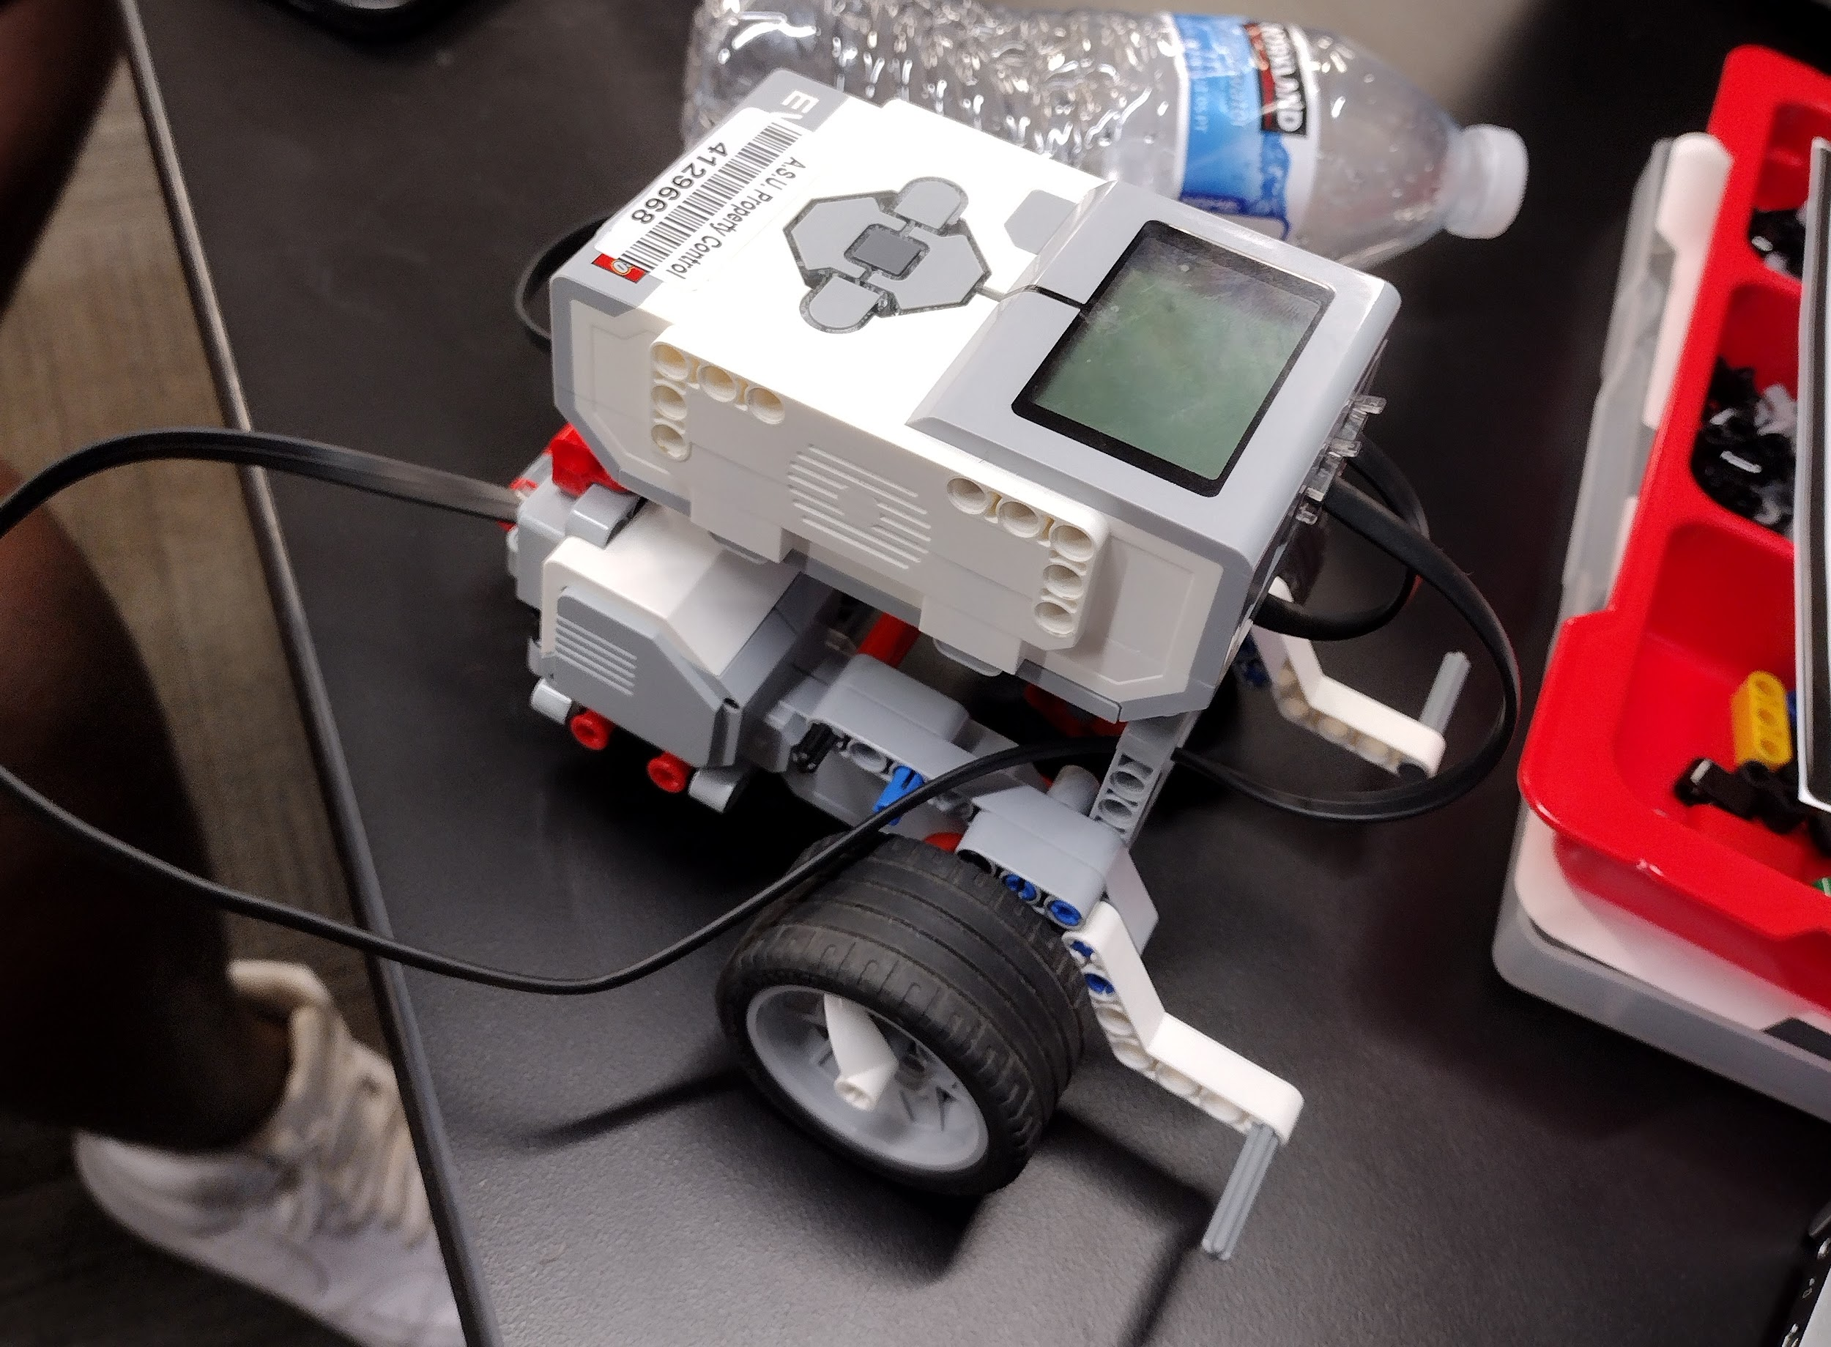

MATLAB Code:
global key;
InitKeyboard();

while 1
pause(0.1);
switch key
case 'uparrow'
disp('Up Arrow Pressed!')
brick.MoveMotor('C', 50);
brick.MoveMotor('B', 50);
case 'downarrow'
disp('Down Arrow Pressed!')
brick.MoveMotor('C', -50);
brick.MoveMotor('B', -50);
case 'rightarrow'
disp('Right Arrow Pressed!')
brick.MoveMotor('C', 50);
case 'leftarrow'
disp('Left Arrow Pressed!')
brick.MoveMotor('B', 50);
case 'q'
disp('End Program!')
break;
end
end
CloseKeyboard();

YouTube Video:

